**Penggunaan Enhanced-Ant-Aodv di MANET Dalam Optimisasi Penunjang Poling Info Keselamatan Lalu Lintas di Traffic Light**

Claus Peter C. H/05111740000090/claus.peter54@gmail.com

Philip Antoni Siahaan/05111740000111/siahaan.philip279@gmail.com

**ABSTRACT**

Didalam paper ini menjelaskan sebuah ide Mobile adhoc network (MANET) untuk mendukung keselamatan dalam lalu lintas melalui info poling. Protocol yang dipakai adalah AODV yang menggunakan algoritma ant colony untuk mendapatkan rute konektivitas yang optimal dalam jaringan. Diasumsikan bahwa setiap pengguna jalan memiliki alat yang terhubung kedalam manet di persimpangan lalu lintas. Pengguna menerima Poling dan memberikan informasi terkait dengan apa yang terjadi didepan ataupun disekitar daerah yang dia jalani, pengguna mengisi polling ketika berhenti menunggu di traffic light ketika lampu berwarna merah. Informasi yang diberi akan menjadi informasi yang penting untuk pengguna lainnya yang dikrim lewat manet.

.

**Keywords**: Manet, AODV, Ant Colony, routing protocol, ns2, Poling .

# Introduction

The document is a template for Microsoft *Word* versions 6.0 or later. This document is adopted from IEEE journal template and customized for JUTI. All articles that will be published must follow this template. All styles (including heading and caption) already included in this document. Use these styles for styling your document.

Jaringan *Ad Hoc* adalah salah satu jenis jaringan komputer berbasis wireless yang menghubungkan dua atau lebih perangkat untuk bisa saling berkomunikasi. Namun pada prakteknya, jaringan *Ad Hoc* sering dipakai untuk menghubungkan 2 perangkat seperti laptop untuk memindahkan data. Jaringan *Ad Hoc* terdiri dari sekumpulan *node-node* yang terhubung satu sama lain secara langsung tanpa melibatkan perantara seperti *access point*. *Node-node* pada jaringan *Ad Hoc* memiliki sifat dinamis. Oleh sebab itu jaringan *Ad Hoc* tidak hanya mampu mengirim dan menerima informasi saja, namun sekaligus dapat mendukung jaringan tersebut untuk dimanfaatkan sebagai *router.* Jaringan Ad Hoc sering digunakan untuk pengembangan Smart City.

Smart City Menjadi banyak solusi dalam kehidupan, mulai dari kesehatan, pendataan, transportasi. Masalah transportasi menjadi salah satu masalah yang masih umum terjadi dalam sebuah kota terutama lalu lintas. Kurangnya informasi dijalan raya terkait dengan kemacetan, kecelakaan dan perbaikan jalan menjadi satu hal yang krusial dalam hal keselamatan lalu lintas, dan bila menunggu berita dan radio memerlukan waktu yang cukup lama untuk menyadari kejadian ditempat sehingga diperlukan pembagian informasi secara cepat tak lama ketika kejadian lalu lintas terjadi seperti apakah jalur didepan sedang ada kemacetan, atau perbaikan jalan. Hal tersebut menjadi penunjang untuk melakukan system poling secara real time untuk berbagi informasi antar pengendara tentang apa yang terjadi di keadaan lalu lintas sekitar secara cepat. Disini system poling akan terakses ketika mendekati network yakni di persimpangan lampu lalu lintas, kemudian node menerima input dan menampilkan poling untuk diisi apakah ada ada masalah lalu lintas disekitarnya.

Diperkembangan teknologi saat ini Sistem MANET atau mobile-adhoc network menjadi salah satu solusi yang baik sebagai system network . Untuk melaukan akses terhadap internet yang terbatas maka dibuatlah manet di setiap traffic light . disamping sebagai hal yang bisa dilakukan selama menunggu di traffic light atau persimpangan lampu lalu lintas, juga sebagai peringatan dan informasi tentang jalan raya yang sedang berlangsung. Telah terdapat penilitian penggunaan MANET terhadap poling dan hasilnya [3] MANET tidak bergantung pada ukuran besar kecilnya halaman web yang diakses, akan tetapi pada jarak antar node. Sehingga diharapkan penggunaan Ant colony pada aodv sebagai pencari jarak antar node terbaik untuk menaikan response time. [3]Enhanced-Ant-AODV membangun rute yang optimal dari sumber ke tujuan dengan mempertimbangkan kualitas link, kemacetan, energi residu dan jumlah hop di sepanjang jalan.

# Related Work

## Enhanced Ant AODV

Enhanced-Ant-Aodv Merupakan Gabungan dari metode Ad-hoc On Demand Distance Vector (AODV) dengan [Ant Colony Optimization](https://www.sciencedirect.com/topics/computer-science/ant-colony-optimisation) (ACO). Tidak sama dengan Manet AODV biasa metode ini memungkinkan untuk mencari rute terlebih dahulu sebelum terjadi pengiriman data antar node. Dalam pencarian route node terbaik tersebut sender nodes akan mengirimkan sebuah paket yang disebut ReqAnts Packet. Dsini metode AOC merupakan metode yang diambil dari semut secara biologis dimana semut-semut akan menyebar pertama kali untuk mencari node tujuan yakni makanan. Setelah menemukannya maka mereka menaruh pheromone di jalur mereka. Sehingga semut lain bisa mendapat informasi dari jalur kemakanan tersebut. Sama pula dengan AOC Reqant disebarkan dalam jaringan dan mengumpulkan informasi tentang jalur rute, apakah rute tersebut efisien, bagaimana kemacetan sepanjang rute dan Panjang rute. Rute dengan feromon tertinggi akan menjadi rute pengiriman informasi terbaik.

Enhanced-Ant-AODV membangun rute yang optimal dari sumber ke tujuan dengan mempertimbangkan kualitas link, kemacetan, energi residu dan jumlah hop di sepanjang jalan. Dari hasil simulasi bedasarkan paper Enhanced-Ant-AODV for Optimal Route Selection in Mobile Ad-Hoc Network [1], dapat dikatakan bahwa Enhanced-Ant-AODV memberikan hasil yang lebih baik dibandingkan dengan Enhanced-Ant-DSR, AODV dan DSR dalam hal rasio pengiriman paket, throughput, keterlambatan akhir hingga akhir dan persentase node yang selamat atau terkena jaringan

## AODV

AODV merupakan singkatan dari Ad hoc On-demand Distance Vector. AODV merupakan reactive routing protocol yang hanya melakukan request sebuah rute saat dibutuhkan. AODV didesain untuk mobile adhoc network(MAN) dengan populasi node sekitar 10 hingga ribuan mobile nodes. AODV mampu mengolah data mobile yang rendah, normal hingga relatif tinggi. AODV didesain untuk digunakan pada nodes yang sudah saling mempercayai, dan tidak diharapkan adanya nodes penggangu. AODV telah dirancang untuk mengurangi penyebaran lalu lintas control dan menghilangkan overhead pada data lalu lintas, untuk meningkatkan skalabilitas dan kinerjanya.

Dalam terminolgoi aodv rute yang dipakai adalah rute yang memiliki tujuan destinasi yang terdapat dalam table yang valid. Broadcasting yang dipakai untuk melakukan penyebaran pesan aodv pada jaringan ad-hoc. Rute yang digunakan menjadi tujuan node dibuat oleh aksi AODV yang membawa alamat IP dari simpul tujuan yang diinginkan dalam rute discovery message. Seluruh pesan AODV dikirimkan dalam port 654 menggunakan UDP.

AODV memilik rute discovery dan route maintenance. Dimana rute discovery adalah RREQ dan RREP untuk route maintenance nya adalah RERR. Sehingga pesan pesan yang dari AODV tidak disiarkan secara acak maupun asal asalan. Selama endpoint dari koneksi komunikasi memiliki rute yang valid AODV tidak melakukan tindakan. Ketika sebuah node meminta rute kesebuah destinasi baru, node akan melakukan broadcast RREQ untuk mencari rute ketujuan node. Route yang ditentukan oleh RREQ merupakan rute yang telah dicapai dalam destinasi yang telah dituju, ataupun sebuah route yang valid. Rute tersebut tersedia karena unicasting sebuah RREP. Setiap node yang menerima sebuah cache route back dari pembuat request awal akan di unicast dari RREP sehingga bisa menyampaiakaan request.

AODV adalah sebuah protokol routing dan memiliki hubungan dengan tabel route management. Informasi yang terdapat dalam table harus tetap rahasia meskipun hanya untuk hubungan singkat dalam rute. Dalam table route AODV memerlukan Destination IP Address, Destination sequence number, Valid destination sequence number flag, sebuah network interface, banyak hitungan hop untuk mencapai destinasi, hop selanjutnya, List prececusor, dan jangka waktu dari penghapusan rute.

## Ant Based Routing Protocol

## Polling system

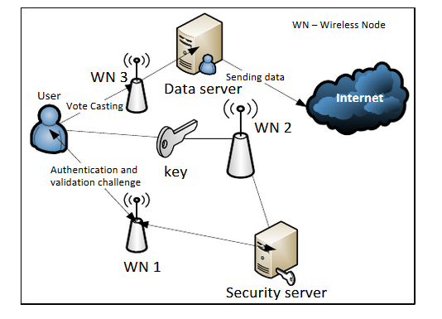Polling system disni merupakan kegiatan polling yang dilakukan secara elektronik dimana pemberi informasi akan masuk kesebuah jaringan yang disini adalah MANET. Pemberi informasi memiliki sebuah perangkat yang menjadi sebuah node dalam jaringan. Node disini akan menerima informasi dan disimpan dalam database yang sudah disediakan. Untuk metodologi yang dipakai

Gambar : operation of a single manet(figure 3 paper[3] )

Untuk membuat sebuah manet polling diperlukan penginstallan dibeberapa tempat dan sebuah data server. Routing protocol yang dipakai dalam system adalah AODV.

## Network Simulator

Network simulator adalah sebuah interpreter yang object oriented dan discrete event driver yang dikembangkan oleh UC Barkley. NS yang saat ini dipakai dipaper ini adalah NS2 merupakan proyek Virtual internet Testbed, sebuah tools untuk menunjukan sebuah simulasi jaringan yang melibatkan LAN, WAN, dan beberapa system jaringan yang telah umum. Network simulator pertama kali dibangun pada tahun 1989.

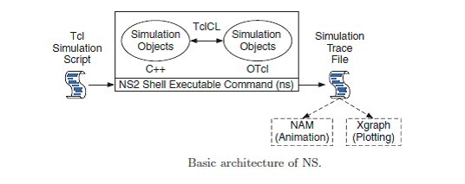

NS2 terdiri dari 2 buah Bahasa pemrograman yakni C++ dan sebuah object oriented command language(OcTcl), tugas C++ adalah melakukan pendefinisian backend dari simulasi dan OcTcl menyediakan perlengkapan simulasi untuk di susun maupun di rakit berdasarkan objek. C++ dan OcTcl saling beKerjasama dan dihubungkan oleh TclCl.

# MATH

If you are using *Word,* use either the Microsoft Equation Editor or the *MathType* add-on (http://www.mathtype.com) for equations in your paper (Insert | Object | Create New | Microsoft Equation *or* MathType Equation). “Float over text” should *not* be selected.

## Equations

Number equations consecutively with equation numbers in parentheses flush with the right margin, as in (1). First use the equation editor to create the equation. Then select the “Equation” markup style. Press the tab key and write the equation number in parentheses. To make your equations more compact, you may use the solidus ( / ), the exp function, or appropriate exponents. Use parentheses to avoid ambiguities in denominators. Punctuate equations when they are part of a sentence, as in

|  |  |
| --- | --- |
|  | (1) |

Be sure that the symbols in your equation have been defined before the equation appears or immediately following. Italicize symbols (*T* might refer to temperature, but T is the unit tesla). Refer to “(1),” not “Eq. (1)” or “equation (1),” except at the beginning of a sentence: “Equation (1) is ... .”

# Units

Use either SI (MKS) or CGS as primary units. (SI units are strongly encouraged.) English units may be used as secondary units (in parentheses). This applies to papers in data storage**.** For example, write “15 Gb/cm2 (100 Gb/in2).” An exception is when English units are used as identifiers in trade, such as “3½-in disk drive.” Avoid combining SI and CGS units, such as current in amperes and magnetic field in oersteds. This often leads to confusion because equations do not balance dimensionally. If you must use mixed units, clearly state the units for each quantity in an equation.

The SI unit for magnetic field strength *H* is A/m. However, if you wish to use units of T, either refer to magnetic flux density *B* or magnetic field strength symbolized as µ0*H*. Use the center dot to separate compound units, e.g., “A·m2.”

# Some Common Mistakes

The word “data” is plural, not singular. The subscript for the permeability of vacuum µ0 is zero, not a lowercase letter “o.” The term for residual magnetization is “remanence”; the adjective is “remanent”; do not write “remnance” or “remnant.” Use the word “micrometer” instead of “micron.” A graph within a graph is an “inset,” not an “insert.” The word “alternatively” is preferred to the word “alternately” (unless you really mean something that alternates). Use the word “whereas” instead of “while” (unless you are referring to simultaneous events). Do not use the word “essentially” to mean “approximately” or “effectively.” Do not use the word “issue” as a euphemism for “problem.” When compositions are not specified, separate chemical symbols by en-dashes; for example, “NiMn” indicates the intermetallic compound Ni0.5Mn0.5 whereas “Ni–Mn” indicates an alloy of some composition NixMn1-x.

Be aware of the different meanings of the homophones “affect” (usually a verb) and “effect” (usually a noun), “complement” and “compliment,” “discreet” and “discrete,” “principal” (e.g., “principal investigator”) and “principle” (e.g., “principle of measurement”). Do not confuse “imply” and “infer.”

Prefixes such as “non,” “sub,” “micro,” “multi,” and “ultra” are not independent words; they should be joined to the words they modify, usually without a hyphen. There is no period after the “et” in the Latin abbreviation “*et al.*” (it is also italicized). The abbreviation “i.e.,” means “that is,” and the abbreviation “e.g.,” means “for example” (these abbreviations are not italicized).

# Guidelines for Graphics Preparation and Submission

## Types of Graphics

The following list outlines the different types of graphics published in JUTI. They are categorized based on their construction, and use of color / shades of gray:

### *Color/Grayscale figures*

### Figures that are meant to appear in color, or shades of black/gray. Such figures may include photographs, illustrations, multicolor graphs, and flowcharts.

### *Lineart figures*

### Figures that are composed of only black lines and shapes. These figures should have no shades or half-tones of gray. Only black and white.

### *Tables*

### Data charts which are typically black and white, but sometimes include color.

## Multipart figures

Figures compiled of more than one sub-figure presented side-by-side, or stacked. If a multipart figure is made up of multiple figure types (one part is lineart, and another is grayscale or color) the figure should meet the stricter guidelines.

## File Formats for Graphics

Format and save your graphics using a suitable graphics processing program that will allow you to create the images as PostScript (PS), Encapsulated PostScript (.EPS), Tagged Image File Format (.TIFF), Portable Document Format (.PDF), or Portable Network Graphics (.PNG) sizes them, and adjusts the resolution settings. If you created your source files in one of the following programs you will be able to submit the graphics without converting to a PS, EPS, TIFF, PDF, or PNG file: Microsoft Word, Microsoft PowerPoint, or Microsoft Excel. Though it is not required, it is recommended that these files be saved in PDF format rather than DOC, XLS, or PPT. Doing so will protect your figures from common font and arrow stroke issues that occur when working on the files across multiple platforms. When submitting your final paper, your graphics should all be submitted individually in one of these formats along with the manuscript.

## Sizing of Graphics

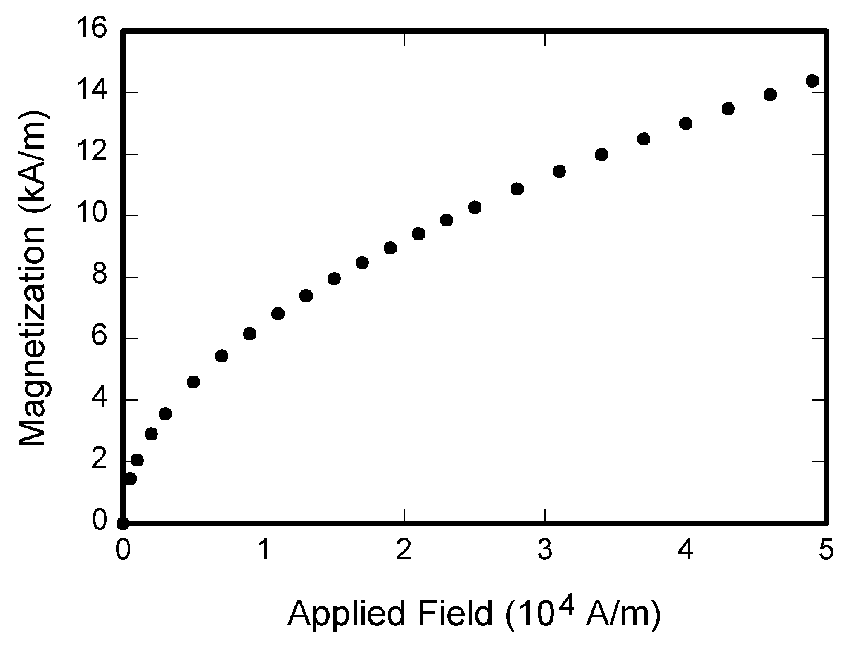

Fig. 1. Magnetization as a function of applied field. Note that “Fig.” is abbreviated. There is a period after the figure number, followed by two spaces. It is good practice to explain the significance of the figure in the caption.

TABLE I

Units for Magnetic Properties

|  |  |  |
| --- | --- | --- |
| Symbol | Quantity | Conversion from Gaussian and  CGS EMU to SI a |
| F | magnetic flux | 1 Mx ® 10-8 Wb = 10-8 V·s |
| *B* | magnetic flux density,  magnetic induction | 1 G ® 10-4 T = 10-4 Wb/m2 |
| *H* | magnetic field strength | 1 Oe ® 103/(4p) A/m |
| *m* | magnetic moment | 1 erg/G = 1 emu  ® 10-3 A·m2 = 10-3 J/T |
| *M* | magnetization | 1 erg/(G·cm3) = 1 emu/cm3  ® 103 A/m |
| 4p*M* | magnetization | 1 G ® 103/(4p) A/m |
| s | specific magnetization | 1 erg/(G·g) = 1 emu/g ® 1 A·m2/kg |
| *j* | magnetic dipole  moment | 1 erg/G = 1 emu  ® 4p ´ 10-10 Wb·m |
| *J* | magnetic polarization | 1 erg/(G·cm3) = 1 emu/cm3  ® 4p ´ 10-4 T |
| c*,* k | susceptibility | 1 ® 4p |
| cr | mass susceptibility | 1 cm3/g ® 4p ´ 10-3 m3/kg |
| m | permeability | 1 ® 4p ´ 10-7 H/m  = 4p ´ 10-7 Wb/(A·m) |
| mr | relative permeability | m ® mr |
| *w, W* | energy density | 1 erg/cm3 ® 10-1 J/m3 |
| *N, D* | demagnetizing factor | 1 ® 1/(4p) |

Vertical lines are optional in tables. Statements that serve as captions for the entire table do not need footnote letters.

aGaussian units are the same as cg emu for magnetostatics; Mx = maxwell, G = gauss, Oe = oersted; Wb = weber, V = volt, s = second, T = tesla, m = meter, A = ampere, J = joule, kg = kilogram, H = henry.

Most charts, graphs, and tables are one column wide (3.5 inches / 88 millimeters / 21 picas) or page wide (7.16 inches / 181 millimeters / 43 picas). The maximum depth a graphic can be is 8.5 inches (216 millimeters / 54 picas). When choosing the depth of a graphic, please allow space for a caption. Figures can be sized between column and page widths if the author chooses, however it is recommended that figures are not sized less than column width unless when necessary.

## Resolution

The proper resolution of your figures will depend on the type of figure it is as defined in the “Types of Figures” section. Author photographs, color, and grayscale figures should be at least 300dpi. Lineart, including tables should be a minimum of 600dpi.

## Vector Art

While JUTI does accept, and even recommends that authors submit artwork in vector format, it is our policy is to rasterize all figures for publication. This is done in order to preserve the figures’ integrity across multiple computer platforms.

## Color Space

The term color space refers to the entire sum of colors that can be represented within the said medium. For our purposes, the three main color spaces are Grayscale, RGB (red/green/blue) and CMYK (cyan/magenta/yellow/black). RGB is generally used with on-screen graphics, whereas CMYK is used for printing purposes.

All color figures should be generated in RGB or CMYK color space. Grayscale images should be submitted in Grayscale color space. Line art may be provided in grayscale OR bitmap colorspace. Note that “bitmap colorspace” and “bitmap file format” are not the same thing. When bitmap color space is selected, .TIF/.TIFF is the recommended file format.

## Accepted Fonts Within Figures

When preparing your graphics JUTI suggests that you use of one of the following Open Type fonts: Times New Roman, Helvetica, Arial, Cambria, and Symbol. If you are supplying EPS, PS, or PDF files all fonts must be embedded. Some fonts may only be native to your operating system; without the fonts embedded, parts of the graphic may be distorted or missing.

A safe option when finalizing your figures is to strip out the fonts before you save the files, creating “outline” type. This converts fonts to artwork what will appear uniformly on any screen.

## Using Labels Within Figures

### Figure Axis labels

Figure axis labels are often a source of confusion. Use words rather than symbols. As an example, write the quantity “Magnetization,” or “Magnetization *M*,” not just “*M*.” Put units in parentheses. Do not label axes only with units. As in Fig. 1, for example, write “Magnetization (A/m)” or “Magnetization (Am-1),” not just “A/m.” Do not label axes with a ratio of quantities and units. For example, write “Temperature (K),” not “Temperature/K.”

Multipliers can be especially confusing. Write “Magnetization (kA/m)” or “Magnetization (103 A/m).” Do not write “Magnetization (A/m) ´ 1000” because the reader would not know whether the top axis label in Fig. 1 meant 16000 A/m or 0.016 A/m. Figure labels should be legible, approximately 8 to 10 point type.

### Subfigure Labels in Multipart Figures and Tables

Multipart figures should be combined and labeled before final submission. Labels should appear centered below each subfigure in 8 point Times New Roman font in the format of (a) (b) (c).

## File Naming

Figures (line artwork or photographs) should be named starting with the first 5 letters of the author’s last name. The next characters in the filename should be the number that represents the sequential location of this image in your article. For example, in author “Anderson’s” paper, the first three figures would be named ander1.tif, ander2.tif, and ander3.ps.

Tables should contain only the body of the table (not the caption) and should be named similarly to figures, except that ‘.t’ is inserted in-between the author’s name and the table number. For example, author Anderson’s first three tables would be named ander.t1.tif, ander.t2.ps, ander.t3.eps.

Author photographs should be named using the first five characters of the pictured author’s last name. For example, four author photographs for a paper may be named: oppen.ps, moshc.tif, chen.eps, and duran.pdf.

If two authors or more have the same last name, their first initial(s) can be substituted for the fifth, fourth, third... letters of their surname until the degree where there is differentiation. For example, two authors Michael and Monica Oppenheimer’s photos would be named oppmi.tif, and oppmo.eps.

## Referencing a Figure or Table Within Your Paper

When referencing your figures and tables within your paper, use the abbreviation “Fig.” even at the beginning of a sentence. Do not abbreviate “Table.” Tables should be numbered with Roman Numerals.

# Conclusion

A conclusion section is not required. Although a conclusion may review the main points of the paper, do not replicate the abstract as the conclusion. A conclusion might elaborate on the importance of the work or suggest applications and extensions.

Appendix

Appendixes, if needed, appear before the acknowledgment.

Acknowledgment

The preferred spelling of the word “acknowledgment” in American English is without an “e” after the “g.” Use the singular heading even if you have many acknowledgments. Avoid expressions such as “One of us (S.B.A.) would like to thank ... .” Instead, write “F. A. Author thanks ... .” In most cases, sponsor and financial support acknowledgments are placed in the unnumbered footnote on the first page, not here.

References and Footnotes

## References

References need not be cited in text. When they are, number citations on the line, in square brackets inside the punctuation. Multiple references are each numbered with separate brackets. When citing a section in a book, please give the relevant page numbers. In text, refer simply to the reference number. Do not use “Ref.” or “reference” except at the beginning of a sentence: “Reference [3] shows ... .” Please do not use automatic endnotes in Word, rather, type the reference list at the end of the paper using the “References” style.

Reference numbers are set flush left and form a column of their own, hanging out beyond the body of the reference. The reference numbers are on the line, enclosed in square brackets. In all references, the given name of the author or editor is abbreviated to the initial only and precedes the last name. Use them all; use et al. only if names are not given. Use commas around Jr., Sr., and III in names. Abbreviate conference titles. When citing journal transactions, provide the issue number, page range, volume number, year, and/or month if available. When referencing a patent, provide the day and the month of issue, or application. References may not include all information; please obtain and include relevant information. Do not combine references. There must be only one reference with each number. If there is a URL included with the print reference, it can be included at the end of the reference.

Other than books, capitalize only the first word in a paper title, except for proper nouns and element symbols. For papers published in translation journals, please give the English citation first, followed by the original foreign-language citation See the end of this document for formats and examples of common references.

## Footnotes

Number footnotes separately in superscripts (Insert | Footnote).[1] Place the actual footnote at the bottom of the column in which it is cited; do not put footnotes in the reference list (endnotes). Use letters for table footnotes (see Table I).

References

[1] Sarkar, Dipika & Choudhury, Swagata & Majumder, Abhishek. (2018). Enhanced-Ant-AODV for Optimal Route Selection in Mobile Ad-Hoc Network. Journal of King Saud University - Computer and Information Sciences. 10.1016/j.jksuci.2018.08.013.

[2] Siddiquee, Kazy Noor E Alam & Andersson, Karl & Khan, Farjana & Hossain, Mohammad. (2017). A scalable and secure MANET for an i-Voting system. Journal of Wireless Mobile Networks, Ubiquitous Computing, and Dependable Applications (JoWUA). 8. 1-17. 10.22667/JOWUA.2017.09.30.001.

[3]Anthony, Eric (2007) Pengaplikasian mobile ad-hoc network (manet) sebagai penunjang audience response system untuk polling system. Bachelor thesis, Petra Christian University.

1. It is recommended that footnotes be avoided (except for the unnumbered footnote with the receipt date on the first page). Instead, try to integrate the footnote information into the text.